Angular JS (UI) Assignments

Assignments Summary:

For an assignment, you need to create the application using Angular JS, HTML 5 & Bootstrap CSS. This application should work on any devices and different browsers means it should be responsive. This application basically divided into three pages.
1) Login with captcha puzzle 2) Video comment screen 3) Graphs

Assignment 2: Video comment screen
Screen1: Video Home
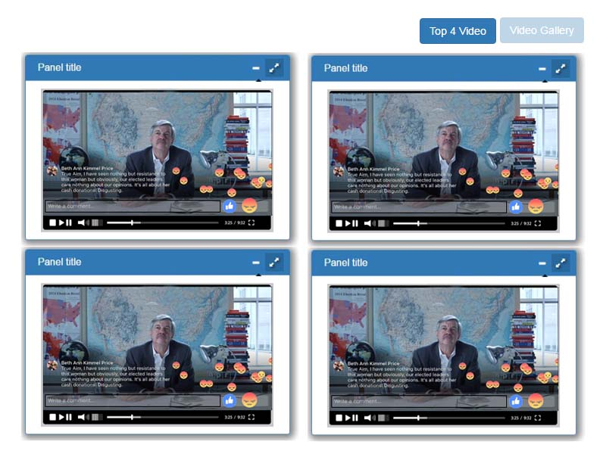
Screen2: Video Gallery

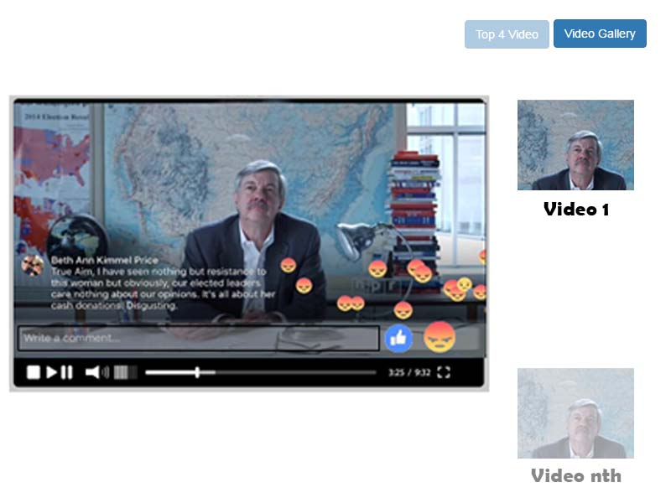

- In this assignment, you need to create the video with comment system for top 4 videos shown in above image.
- This top 4 video should load in animated windows. These windows should have minimized and maximized buttons.
- It should work as docking window system like the operating system of Windows.
- This layout should need to divide into Video Gallery layout and four panels of window layout as shown in above images.
- On first time load, it will show the top four video with four, panels of window layout. And if the user clicks on gallery button then it would load all video files in the gallery from JSON data.
- Create your own video player which should have the following features
  - Play, Pause & Stop button
  - Progress/streaming bar with total time & remaining time for video
  - Video sound controller
  - Full screen button for video
  - If the gallery mode will be on then back next button gets enabled otherwise for 4x4 window layout would in hiding state.
  - Add a comment text box & button on video
  - Mute/Umute button.

- Write/design the valid JOSN file to load the video & it comments objects
- When a user adds the comment to video it should appear from the bottom of video & will disappear at the centre of video with nice animation effect. And if the user wants to see all comment then it would load in a modal window. Please refer the mobile based Fcebook app for video comment animation effect.
- Each video should have the Like, Unlike button. When user like or unlike the video the like icon or unlike icon should appear from right to left with nice animation effect after certain interval of time
- Added comment should save at runtime object from JSON structure.
- When the video screen initially get loaded all video will play with mute.
- If user unmute the particular video, then that video will play with sound and others will remain in mute state and vice versa

Note:
- You can use the Angular JS & Bootstrap library to implement the above functionality.
- Try to create own code. Don’t copy/paste or use third-party library or code. It can easily get noticed.
- Use the OOP JS concepts.
- The code for assignment 2 need to write in Angular JS concepts.

Reference links:
- https://angularjs.org/
- http://getbootstrap.com/css/

Assignment 2 submission details:

Submission Status | Not attempt
Grading | 3.x
Due date for Assignments 2 | Mon, 10 July 2017, 11.00 am.
Submission comments

